Task 1: Create Azure Budget Alerts
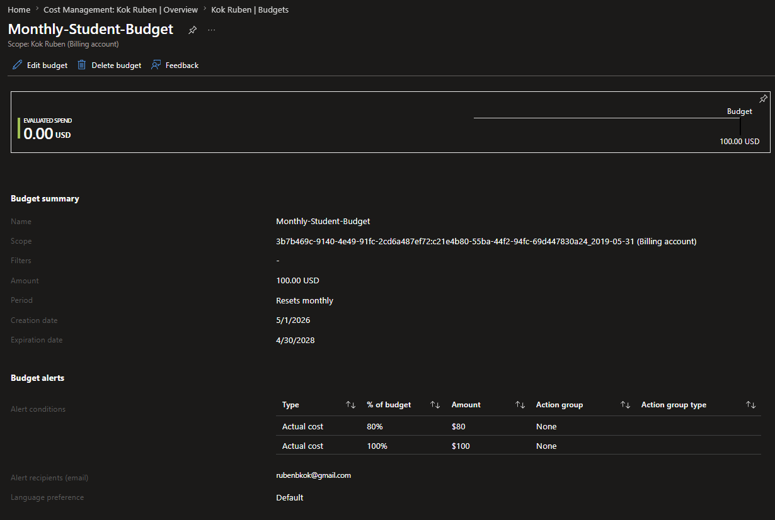
Task 2: Monitor Usage and Adjust Resource Settings
